**Portfolio Colors and Fonts**

**Colors**

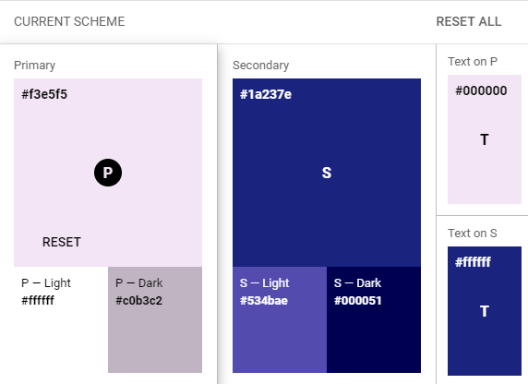

Primary: **#f3e5f5**

Primary Light: **ffffff**

Primary Dark: **#c0b3c2**

Secondary: **#1a237e**

Secondary Light: **#534bae**

Secondary Dark: **#000051**

Text on P: **#000000**

Text on S: **#ffffff**

**Fonts**

1. font-family: 'Bebas Neue', cursive; (H1)
2. font-family: 'Dosis', sans-serif; (Text)
3. font-family: 'Merriweather Sans', sans-serif; (H2)